Romiyo Lager

CIS233DA

Before you come to class

A screenshot of filling system

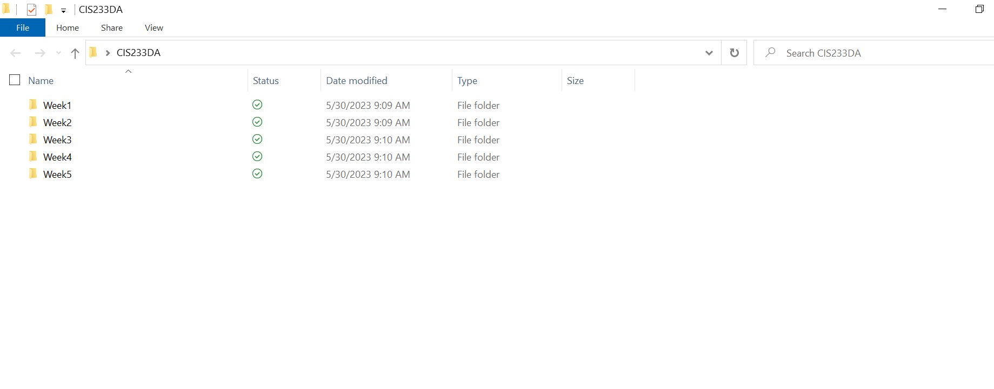

B. Screenshot of VS Code Welcome screen

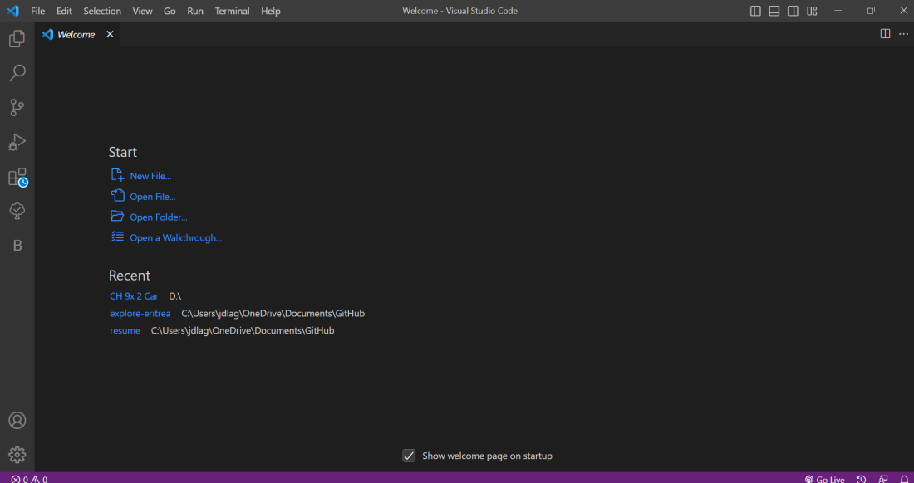

C. URL of GitHub repository

https://github.com/romeol23/CIS233DA.git